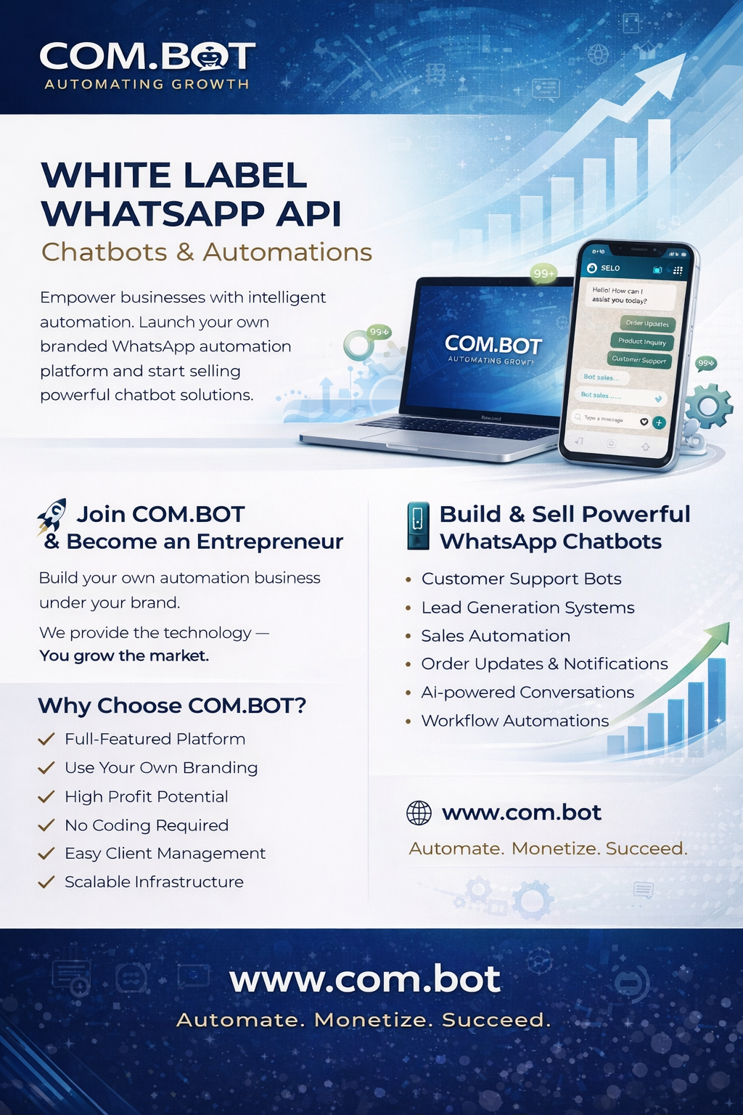

White-Label Communication Platform

Built to Power Agencies. Designed to Scale Businesses.
Launch your own fully-branded communication platform backed by enterprise-grade technology. Our white-label solution empowers digital agencies and SMS companies to deliver powerful customer engagement experiences while generating consistent recurring revenue.

Why Agencies Choose Our White-Label Platform
- Official Meta Business Partner
- Trusted by 50,000+ active users
- Handles 25M+ messages every day
- Over 500,000 bots created
- 99.9% uptime with global infrastructure
- Built for scale, security, and performance
This is not just a tool — it’s a business-ready platform.

A Complete Feature Ecosystem

WhatsApp Business API
Enterprise-grade WhatsApp messaging with official Meta access.
Enable your clients to communicate with customers on the world’s most trusted messaging platform.
What makes it powerful:
- Official WhatsApp Business API integration
- Real-time message delivery with webhooks
- Personalized bulk messaging at scale
- Enterprise-level security and compliance
- High delivery reliability and performance

Facebook Messenger Integration
Seamless Facebook Messenger automation for social engagement.
Turn conversations into conversions with intelligent messaging.
Key advantages:
- Direct Facebook API integration
- Automated replies and chatbots
- Customer insights and engagement analytics
- Multi-agent support for teams
- Unified conversation management

Instagram Integration
Smart Instagram DM automation built for social commerce.
Engage customers instantly on Instagram and never miss a lead.
Key capabilities:
- Instagram DM automation
- Story mentions and comment tracking
- Engagement analytics and performance insights
- Social commerce integrations
- Centralized inbox for teams

Intelligent CRM
A smart CRM designed for modern customer journeys.
Understand, segment, and engage customers like never before.
Core benefits:
- Smart customer segmentation
- Automated tagging and attributes
- Advanced search and filtering
- Complete customer journey tracking
- Centralized customer profiles

Visual Bot Builder
Build powerful chatbots without writing a single line of code.
Design beautiful, intelligent conversations in minutes.
Why teams love it:
- Drag-and-drop bot builder
- Ready-to-use conversation templates
- AI-powered automated responses
- Multi-language support
- Fast deployment across channels

Calendar Bot
Smart appointment booking made effortless.
Automate scheduling and reduce no-shows automatically.
Key features:
- Automated appointment scheduling
- Google & Outlook calendar integration
- Smart reminder notifications
- Booking analytics and insights
- Seamless customer experience

Event Tickets Bot
End-to-end event ticketing with QR-based check-in.
Perfect for conferences, meetups, and large-scale events.
What it delivers:
- Digital ticket generation
- Secure QR code validation
- Automated event check-in
- Real-time attendance tracking
- Scalable event operations

Dynamic QR Bot
Smarter QR codes with real-time intelligence.
Track, analyze, and optimize campaigns instantly.
Key highlights:
- Dynamic QR code creation
- Real-time campaign performance tracking
- Advanced analytics dashboard
- Custom branding options
- Actionable insights

Loyalty & Rewards
Turn customers into loyal brand advocates.
Reward engagement automatically and boost retention.
Features include:
- Loyalty point tracking
- Automated reward distribution
- Customer engagement campaigns
- Loyalty performance analytics
- Retention-focused automation

Dynamic Experiences
Create visually stunning, personalized customer experiences.
Go beyond text with rich, interactive content.
Capabilities:
- Dynamic content generation
- Personalized image creation
- Interactive HTML experiences
- Real-time customization
- Higher engagement rates

Unified Team Inbox
One inbox. Every channel. Total control.
Enable teams to collaborate efficiently across platforms.
Key benefits:
- Multi-channel inbox management
- Message assignment and routing
- Internal collaboration tools
- Agent performance analytics
- Faster response times

Automation Builder
Automate everything. Scale effortlessly.
Build advanced workflows without complexity.
What you get:
- Visual workflow builder
- 1000+ third-party integrations
- Custom trigger conditions
- Advanced automation actions
- End-to-end process automation

Enterprise-Grade Capabilities

Multi-Channel Communication
Engage customers across WhatsApp, Facebook, Instagram, and more — all from one platform.
- Real-time message sync
- 99.9% uptime guarantee
- Production-ready infrastructure

AI-Powered Automation
Deliver 24/7 intelligent customer experiences.
- AI-powered responses
- Smart routing and workflows
- Automated customer journeys

Enterprise CRM & Analytics
Make data-driven decisions with confidence.
- Advanced segmentation
- Real-time analytics
- Custom data fields

Technical Excellence You Can Trust

Enterprise Security
Bank-grade protection for your business and your clients.
- SOC 2 Type II compliance
- End-to-end encryption
- Role-based access control
- Data privacy and isolation

High-Performance Infrastructure
Built to scale globally without compromise.
- Global CDN distribution
- Auto-scaling architecture
- Real-time message delivery

Developer-Friendly Platform
Built for flexibility and customization.
- REST APIs & Webhooks
- SDK support
- Detailed documentation

Advanced Data Management
Secure, compliant, and reliable data handling.
- Automated backups
- GDPR compliance
- Data export and recovery
- Real-time insights
THANK YOU.

Our trusted partners:



